**Setting up a DSN for your ODBC Connection**

Step 1: Search “ODBC” in the Start Menu search and open “ODBC Data Source Administrator (64-bit)”.

Step 2: Select “Add” under the “User DSN” tab.

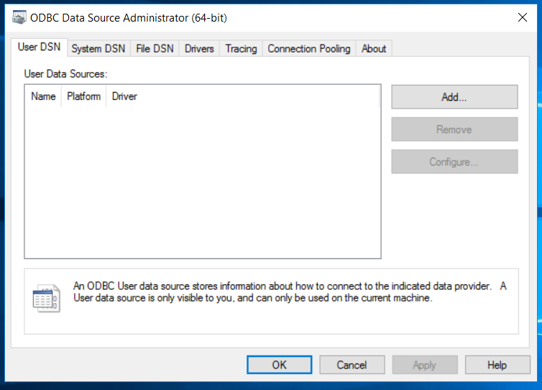

Step 3: Select the corresponding ODBC driver for which you wish to set up a data source and Click “Finish”.

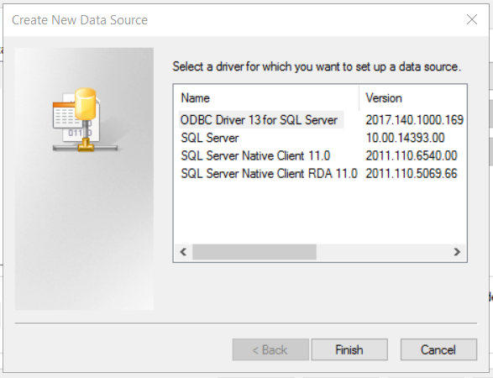

Step 4: Give your DSN a “Name” and “Server” name/IP address and click “Next”.

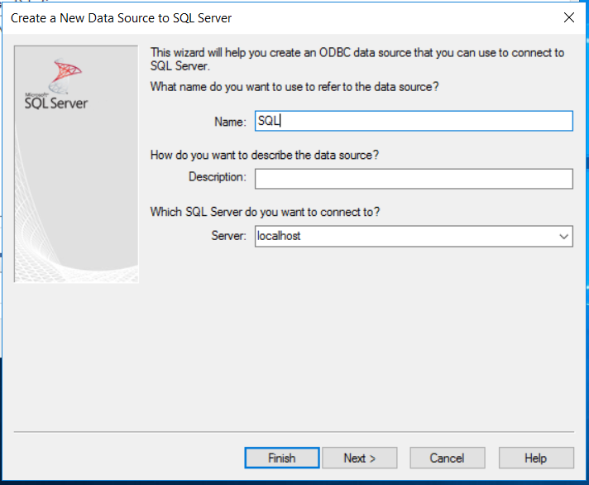

Step 5: Define your default database and click “Next”.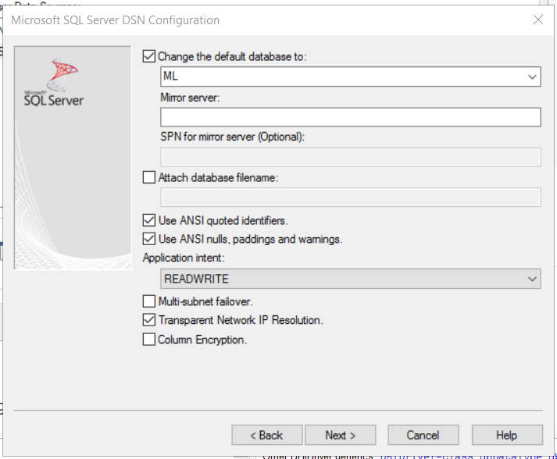

Step 6: Click “Next” through any remaining windows, then click “Finish”. A window should pop up to test the connection. Double check your options then click “Test Data Source…”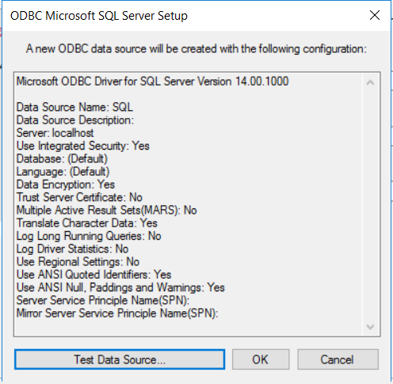

Step 7: If it was successful it should give you the following message. Click “OK”.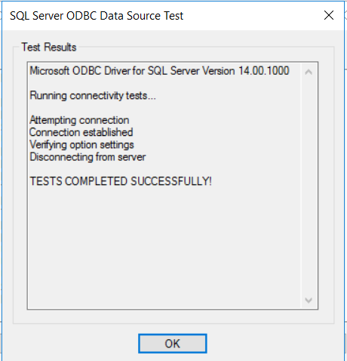

Step 7: Finally you should see your newly defined DSN listed under the “User DSN” tab. Click “OK” to exit the ODBC DSN configuration tool.

